**Java Final Hands-On Exam**

**OUTPUT:**

**Configuration check done**

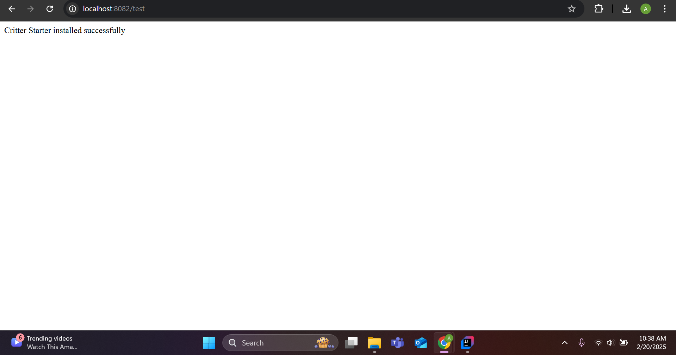

**Task 1: Configure Properties**

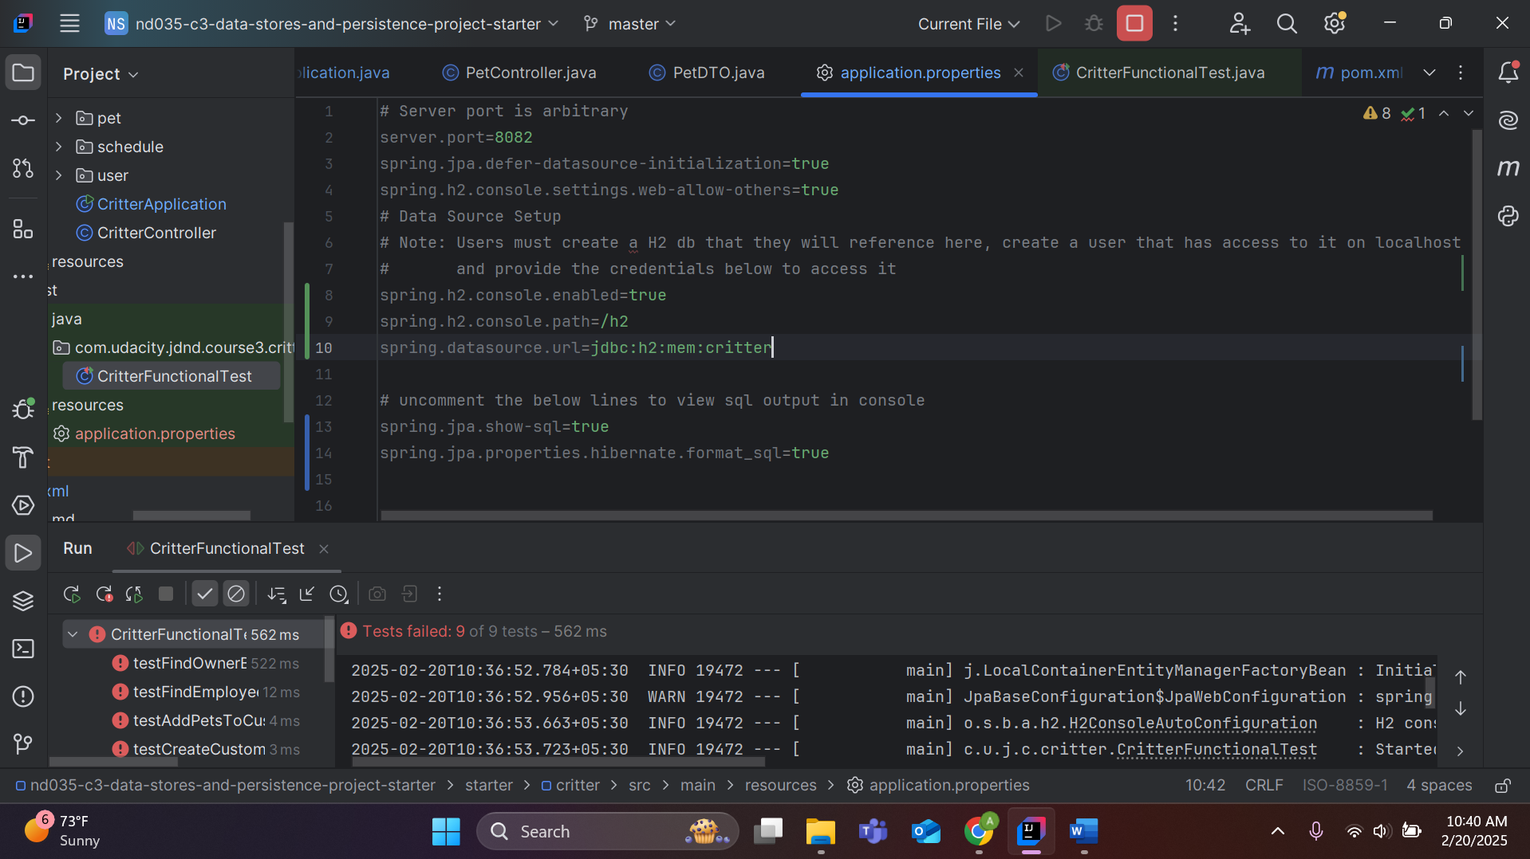

**Task 2: Configure Unit Tests**

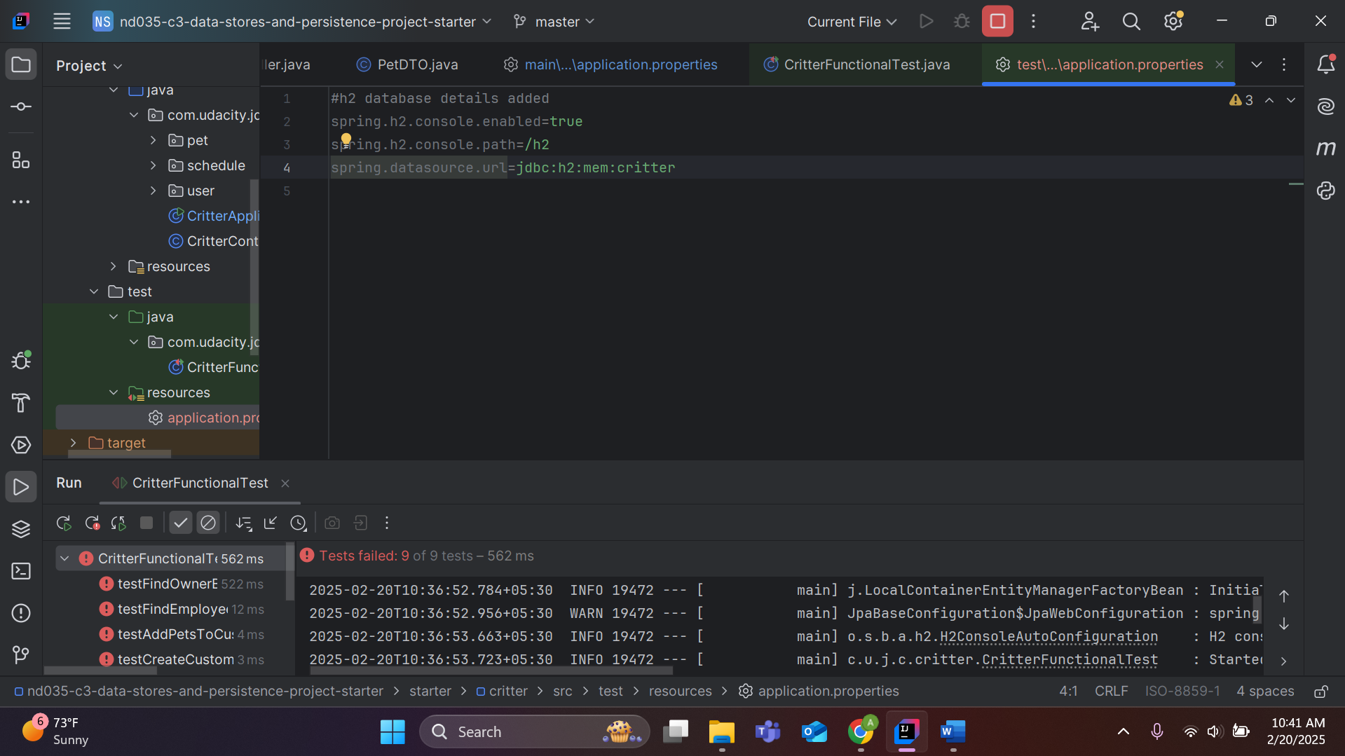

**All the 9 test cases should fail at the beginning, because the starter project controller methods are incomplete, but will be successfully executed once code will be written (as mentioned in the task details)**

**Task 3: Design Entities To Represent Your Data**

1. **Two different kinds of users - Employees and Customers.**

**Customer:**

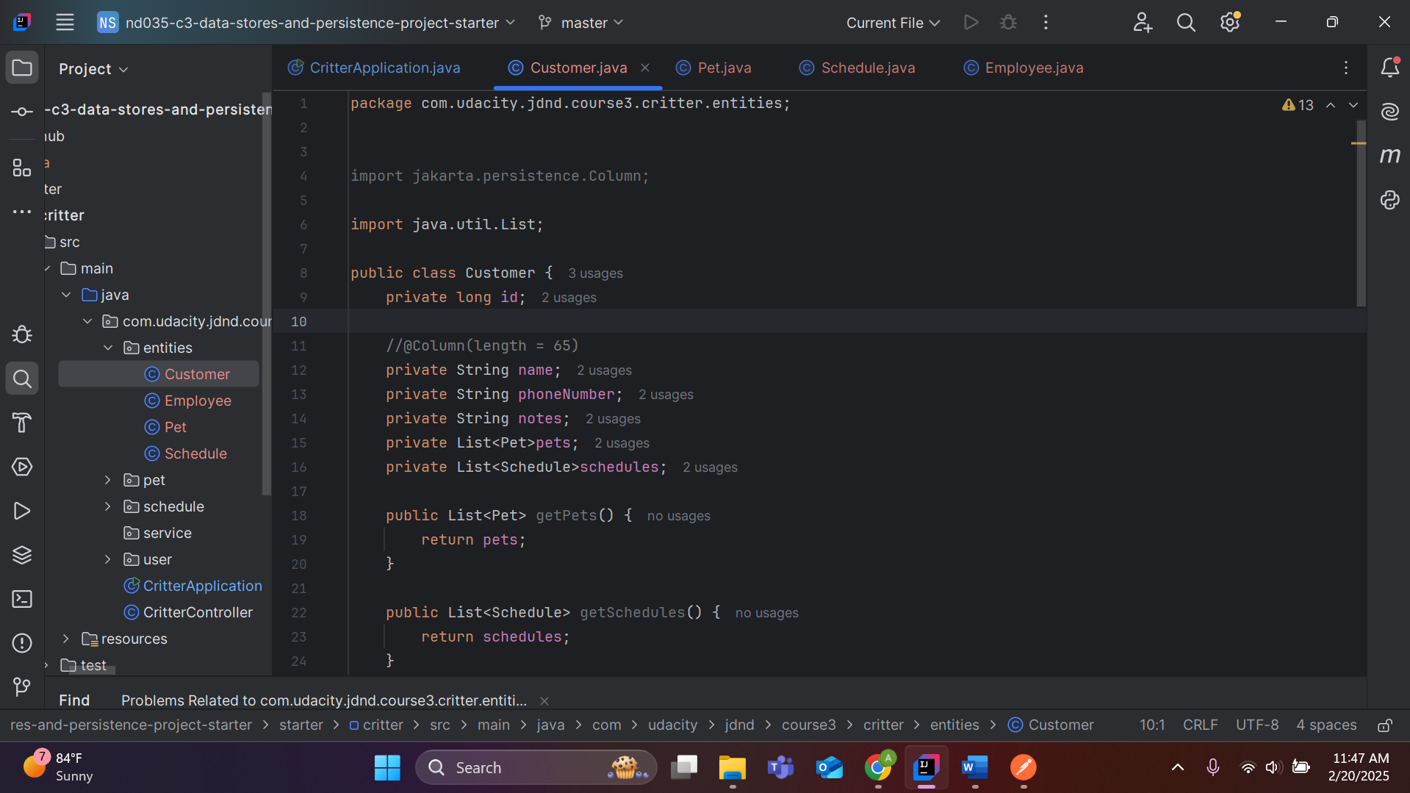

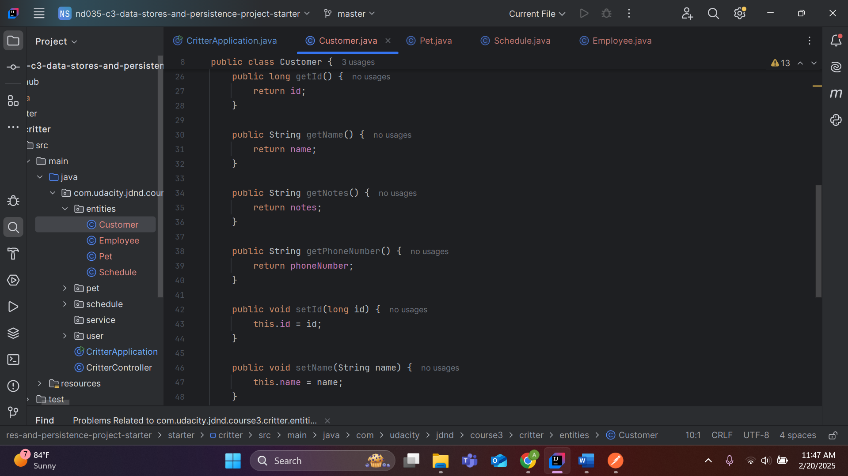

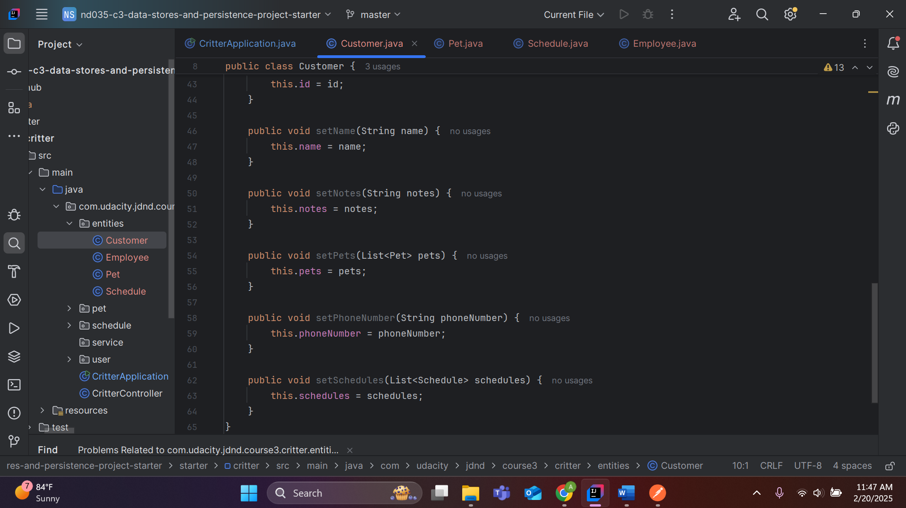

**Employees:**

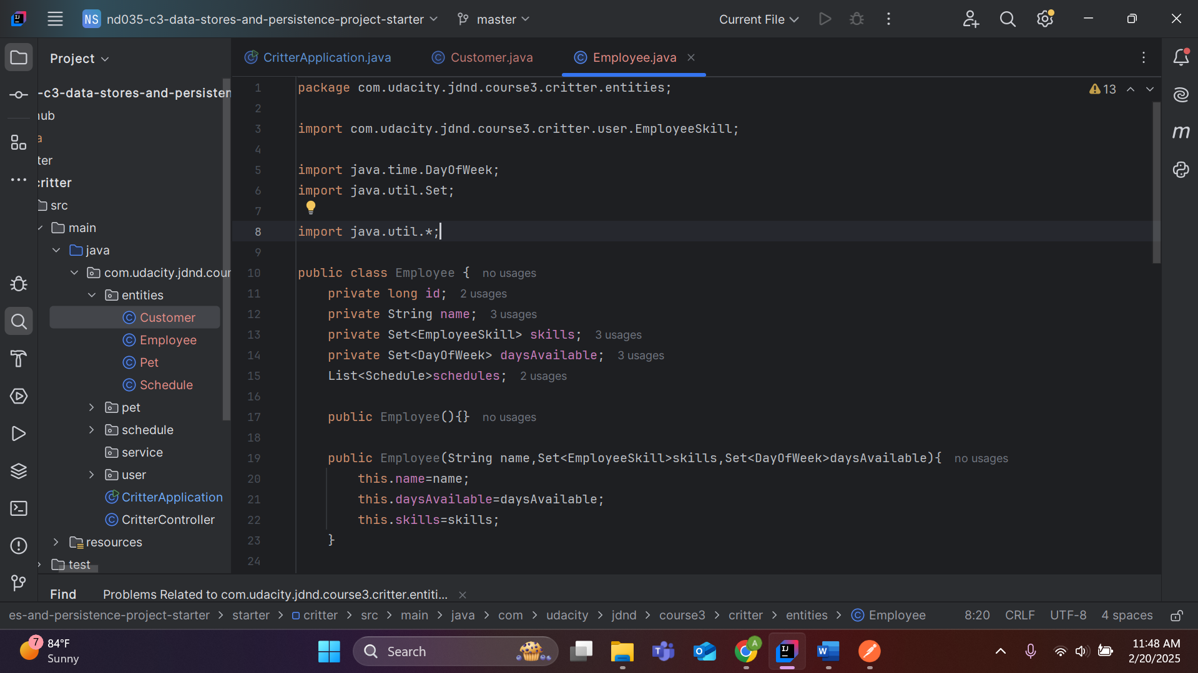

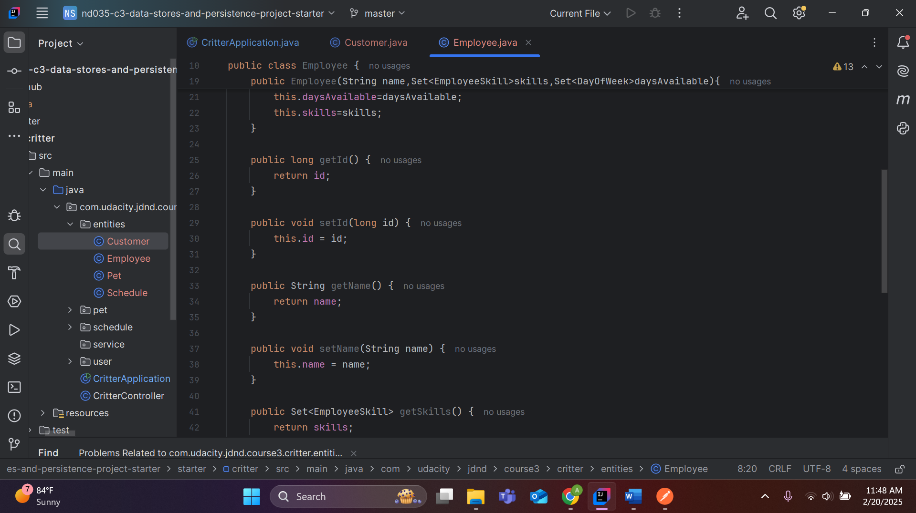

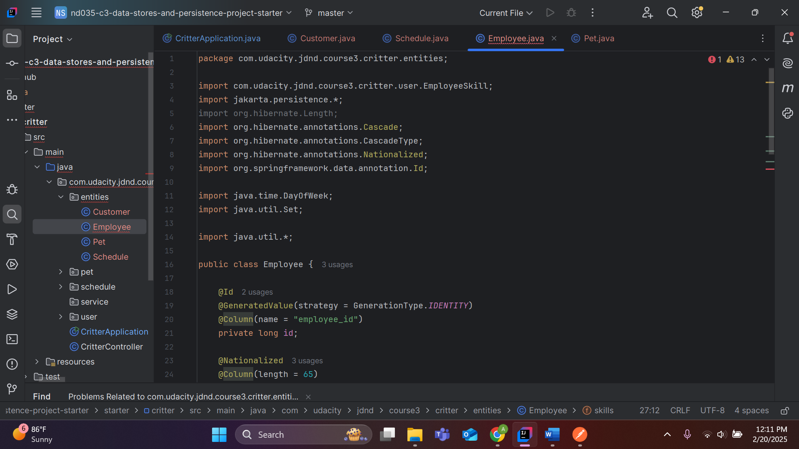

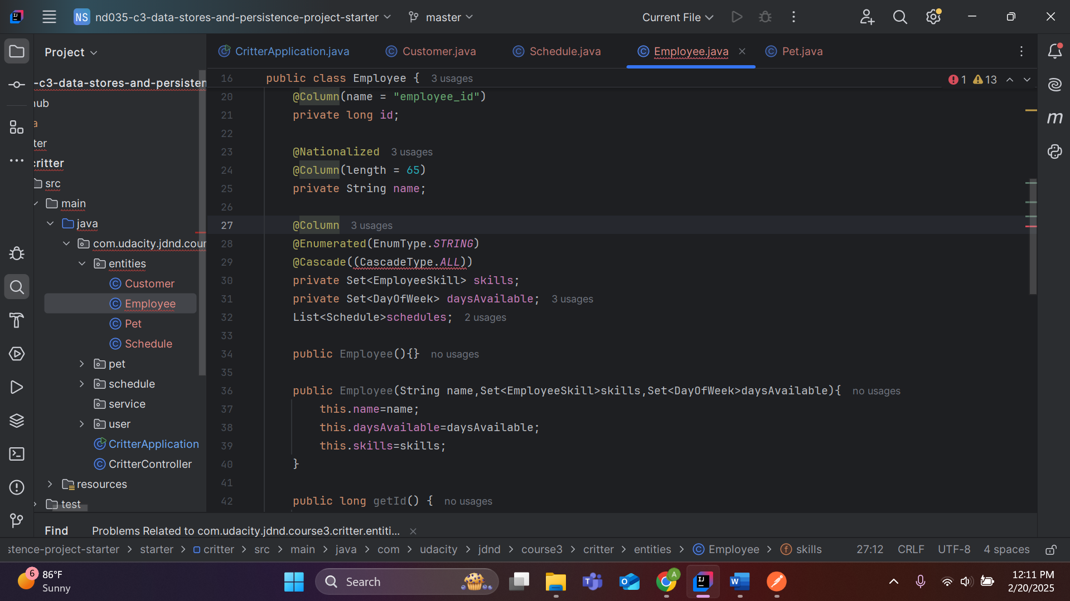

**Task 4: Create Tables in your Database**

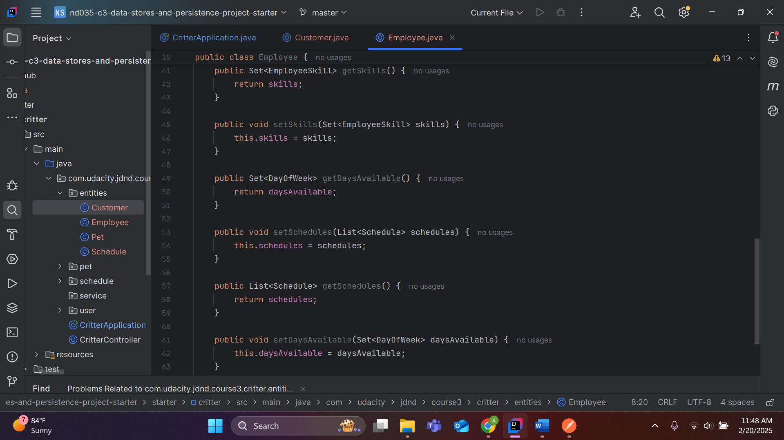

1. **Any type of pet, such as cats, dogs, lizards, hedgehogs, toucans, etc. We don't want to discriminate against owners of odd pets!**

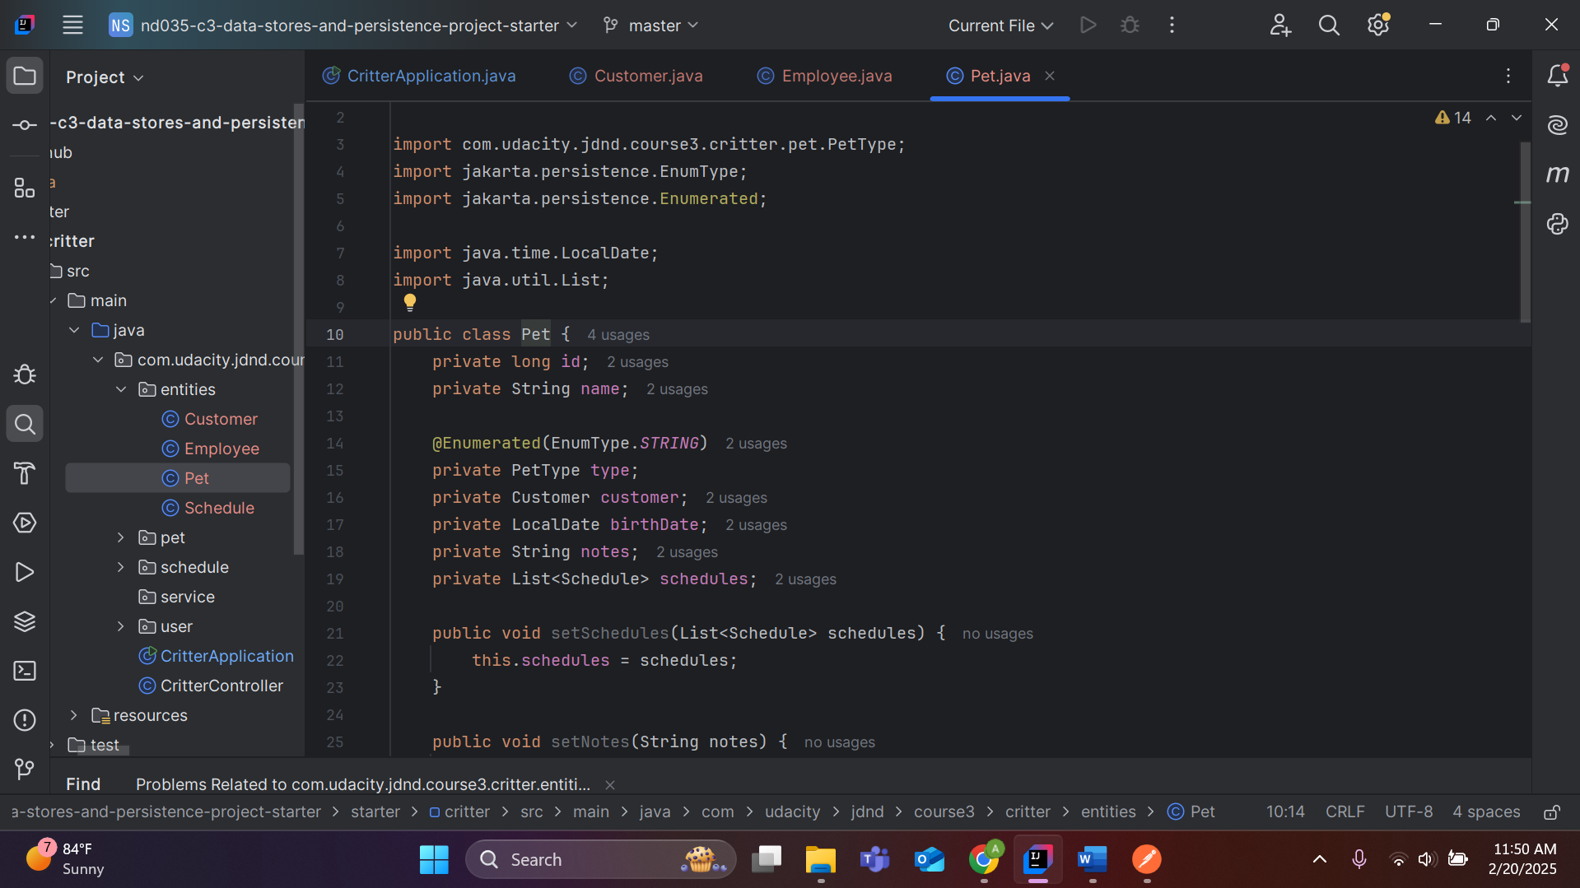

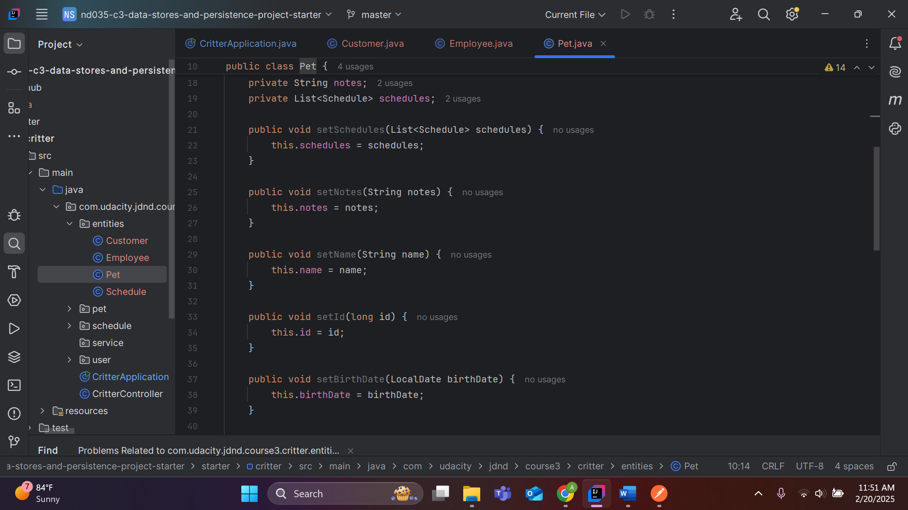

1. **Schedules that indicate one or more employees will be meeting one or more pets to perform one or more activities on a specific day.**

